Kyushu Institute of Technology

Department of Applied Science for Integrated System Engineering





**BIRDS-X Project**

**DRAGONFLY**

**Inhibit Function Test Report**

|  |  |  |  |
| --- | --- | --- | --- |
| **Date** | **Revision Number** | **Writer** | **Annotations** |
| 2024/03/04 | 1.0 | Zamba Leonel | Initial release |
| 2024/08/23 | 2.0 | Yudai Etsunaga | 6.1-6.4 Fixes |
| 2024/08/29 | 3.0 | Sirash | 6.1-6.2 Fixes |
| 2024/09/09 | 4.0 | Sirash | DC/DC Test fixes |

**Table of Contents**

1 Purpose 3

2 Test Objectives 3

3 Test Content 3

3.1 Evaluation Method 3

3.2 Success Criteria 3

4 Test Condition 3

5 Test Results 7

6 Other Qualification Tests 11

6.1 DC/DC Converter Test (for overcharge) 11

6.2 DC/DC Converter Test (Over Discharge and external short) 13

6.3 Diode Test 15

6.4 MOSFET Test 17

6.5 Insulation Process 18

7 Conclusion 19

# 1 Purpose

The purpose of this document is to show that project BIRDS-X, DRAGONFLY satellite has Inhibit functions after environment test. Other qualification tests for launching requirements are also included in this document for verification purposes.

# 2 Test Objectives

The Inhibit Function Test is performed to ensure that the satellite is secured from possible hazards caused by over-charging and over-discharging of the satellite’s batteries while stored inside the J-SSOD before and during launch. Moreover, other qualification tests are performed and presented here in this document to show that the satellite has sufficient protection from hazards including internal short circuit to satisfy JAXA launching requirements.

# 3 Test Content

The inhibit test is conducted with Flight Model (FM) of DRAGONFLY. A total of four (4) inhibits (SepSW1, SepSW2, SepSW3 and SepSW4) operated by three (3) deployment switches (DepSW1, DepSW2 and DepSW3) are in the satellite. The satellite will be turned on when all DepSWs are released. On the other hand, the satellite will turn off when any one or all deployment switches are pressed.

## 3.1 Evaluation Method

The tests for the satellites are conducted with 4 patterns. Evaluation method is whether the satellite is turned ON or OFF with 4 patterns. Evaluation pattern is shown in Table 3.1.

**Table 3.1 Test pattern**

|  |  |  |  |  |
| --- | --- | --- | --- | --- |
| Pattern | 1 | 2 | 3 | 4 |
| DepSW1 | ◯ | × | × | × |
| DepSW2 | × | ◯ | × | × |
| DepSW3 | × | × | ◯ | × |
| Satellite state | OFF | OFF | OFF | ON |

Legend:

◯：pressed

× ：released

## 3.2 Success Criteria

Main purpose of this test is to check if each switch independently functions to inhibit or not. Each switch should be checked to see if the satellite remains in an OFF-state when any one switch is individually pushed while the other switches are in a released state. To satisfy the launch requirements, all inhibits should function properly.

# 4 Test Condition

When the satellite is in OFF-state and the H8 debugger is connected between the satellite and the monitor, there should be no output in the serial display. The satellite is in OFF-state when one of the Inhibits is pressed, there should be no serial data displayed on the PC serial monitor. The satellite is in ON-state when 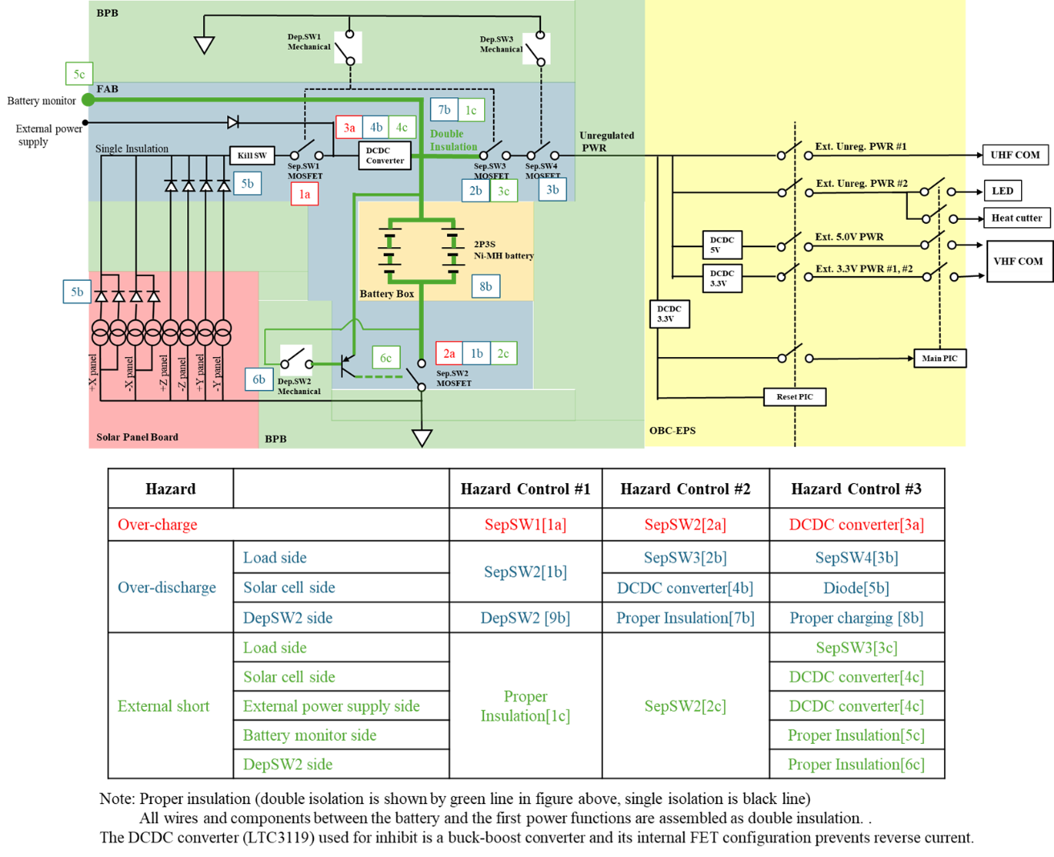all inhibits are released, as such, the satellite should display information on the PC.

**Figure 4.1 EPS Inhibit block diagram**

Figure 4.1 shows the EPS configuration and placement of the inhibit switches and the protection circuits of the DRAGONFLY. Sections 1a, 2a, and 3a are for overcharge protection while sections 1b, 2b, 3b (load side), 1b, 4b, 5b, (solar cell side) and 1b, 6b, 7b (external power fully side) are for over-discharge protection of the satellites. In addition, 1c, 2c, 3c sections (load side), 1c, 2c, 4c (solar cell side) and 1c, 2c, 5c (external power sully side) are for short circuit protection.

SepSW1 and SepSW3 are operated by DepSW1, SepSW4 is operated by DepSW3, and SepSW2 is operated by DepSW2. Inhibits (SepSW2, SepSW3 and SepSW4) from the battery to the load side are verified by the following method.

## DepSWs Test Method

When the satellite is in OFF-state and the H8 debugger is connected between the satellite and the monitor, there should be no output in the serial display. OFF-state of the satellite is when one of the Inhibits is pressed. The satellite is in ON-state when all inhibits are released, as such, the satellite should display information on the PC. Test configuration is shown in Figure 4.1-1.

The following were performed during the test:

1. To check the DepSW1, pressing it shall keep the satellite OFF. There shall be no display in serial monitor, which proves DepSW1 is functional. (Pattern #1)
2. Press DepSW2 prior releasing the DepSW1. There shall be no display in serial monitor, which proves DepSW2 is functional. (Pattern #2)
3. Press DepSW3 prior releasing the DepSW2. There shall be no display in serial monitor, which proves DepSW3 is functional. (Pattern #3)
4. Release all switches. The satellite shall turn ON and the serial monitor shall display the serial output from the OBC. (Pattern #4)

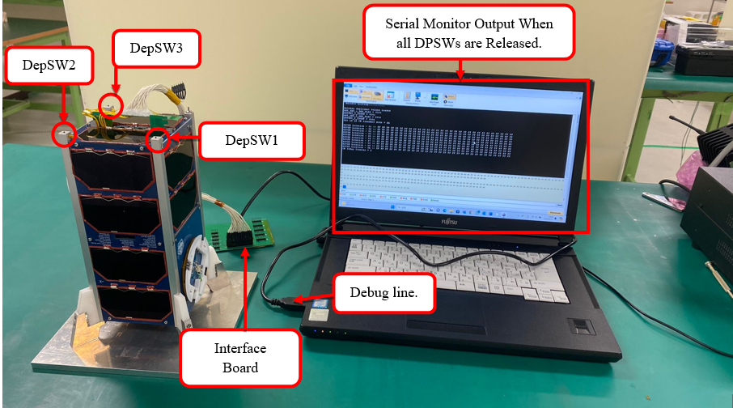**Figure 4.1-1 DepSW1, DepSW2 and DepSW3 Test configuration**

## SepSW1 Test Method

SepSW1 is verified by the following test. As shown in Figure 4.2-1, SepSW1 is on the battery charging line from solar panels, preventing battery charging from solar panel side. Place the satellite in front of a solar simulator with DepSW2 and DepSW3 released. When the satellite is exposed to the light of the solar simulator, the Inhibit (SepSW1) prevents the battery from charging when DepSW1 is pressed. On the other hand, after DepSW1 is released, charging of the battery will start. Therefore, the functionality of SepSW1 can be confirmed by checking the source voltage to the battery from the solar panels. Test configuration and the measurement points are shown in Figure 4.2-1 and Figure 4.2-2.

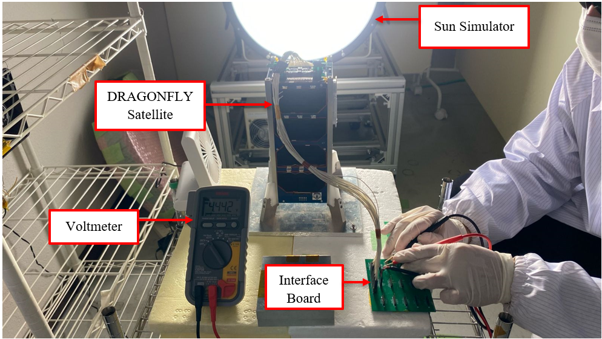

**Figure 4.2-1 SepSW1 Test configuration**

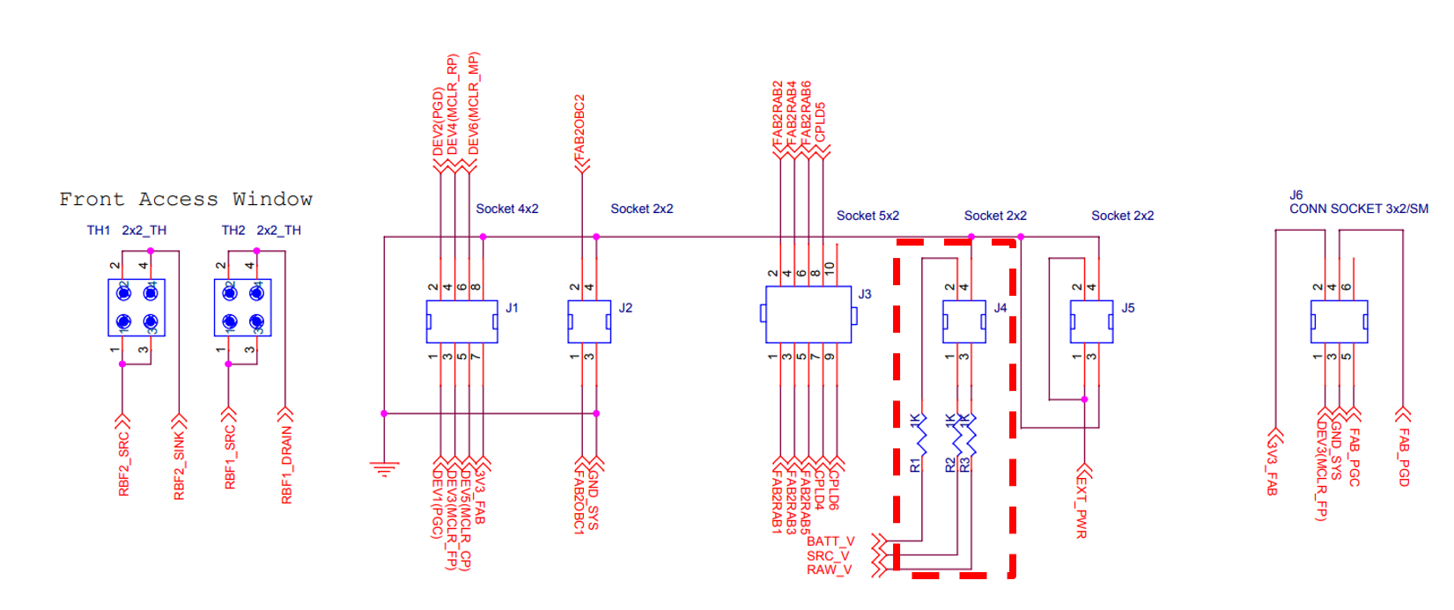

**Figure 4.2-2 Measurement points**

## DepSWs Stroke Measurement

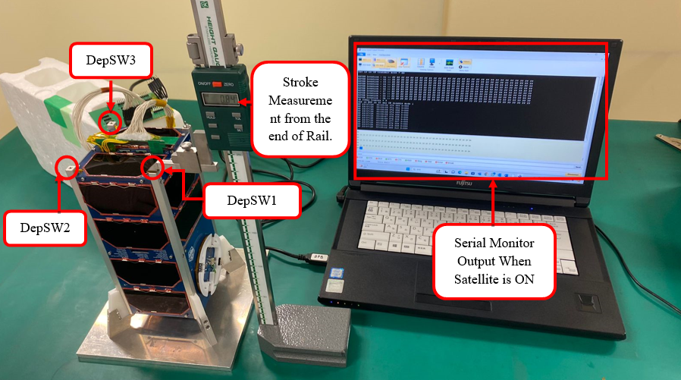 As a requirement for the stroke of the deployment switch, it should be OFF within 0.75mm from the rail end. Place the satellite on the surface plate and push one deployment switch completely with the height gauge. Other two deployment switches are ON. We inspect if the satellite is turned on when the deployment switch is returned by 0.75 mm or more. If the satellite is turned on, the serial data will be output to the PC connected to the satellite via the debugger. Figure 4.3-1 shows the configuration of the stroke test for the deployment switch.

**Figure 4.3-1 Configuration of the stroke test for deployment switches**

# 5 Test Results

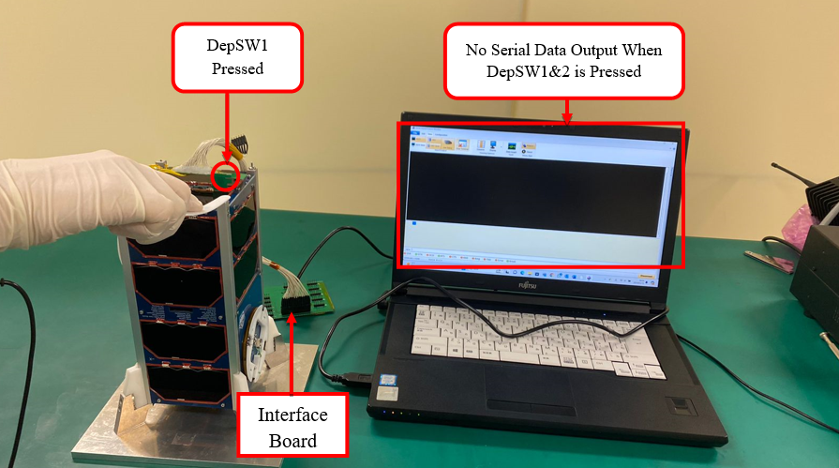 Figure 5.1 shows that when DepSW1 was pressed, the serial monitor showed no sign of response. The satellite was in OFF-state.

**Figure 5.1 Only DepSW1 is pressed (Pattern #1)**



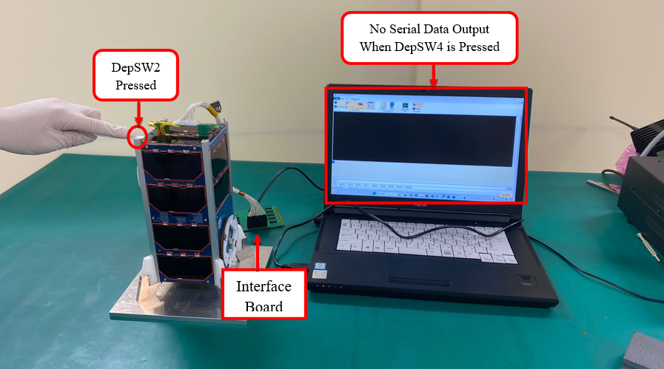 Figure 5.2 shows that when DepSW2 was pressed, the serial monitor showed no sign of response. The satellite was in OFF-state.

**Figure 5.2. Only DepSW2 is pressed (Pattern #2)**

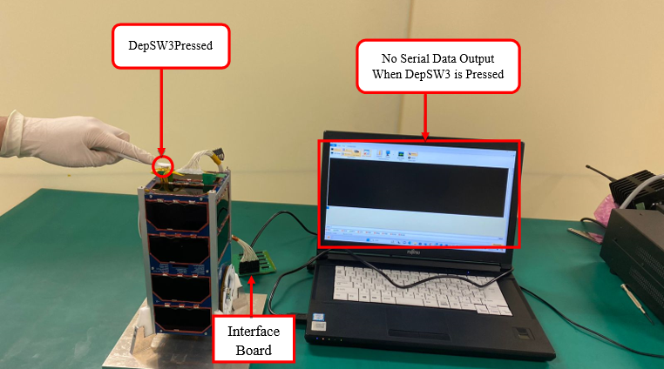 Figure 5.3 shows that when DepSW3 was pressed, the serial monitor showed no sign of response. The satellite was in OFF-state.

**Figure 5.3. Only DepSW3 is pressed (Pattern #3)**

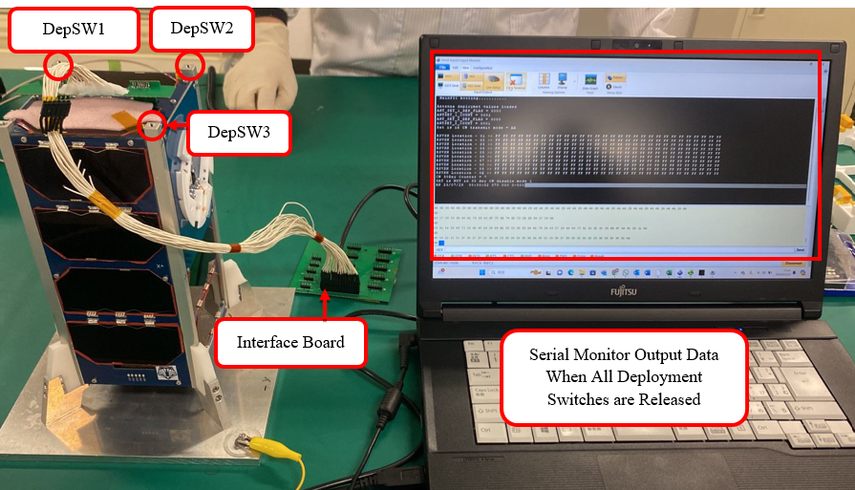 Figure 5.4 shows pattern #4 when the satellite is released from the J-SSOD and the deployment switches are no longer pressed, the serial monitor responded and showed that the satellite was functional. The satellite was in ON-state. Hence, all inhibits were confirmed functional.

**Figure 5.4. DepSW1, DepSW2 and DepSW3 are released (Pattern #4)**

The satellite was exposed to the sun simulator. With DepSW1 released, SepSW1 is ON and the source voltage was 4.143V as recorded by the voltmeter. However, when DepSW1 was pressed, SepSW1 inhibits, and the source voltage starts to drop.  
Therefore, the ON-OFF of SepSW1 controlled by DepSW1 is confirmed functional.

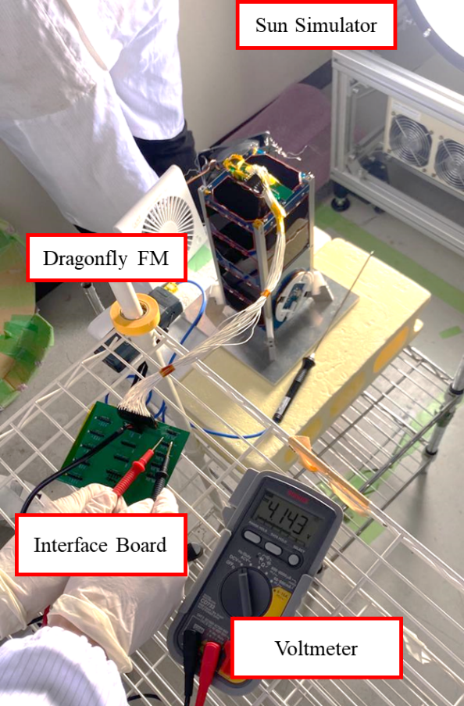

**Figure 5.5 Functionality check of SepSW1. (Press DepSW1)**

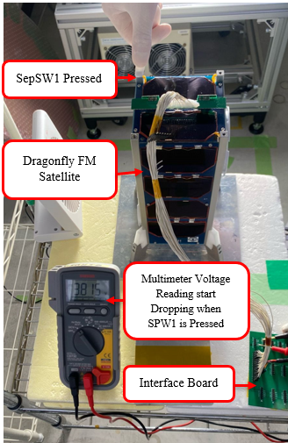

**Figure 5.6 Functionality Check of SepSW1. (Press DepSW1)**

Interface Board

When each DepSW1 was returned 0.75 mm from the rail end face, it was confirmed that the satellite was OFF. The results is shown in Figure 5.7. DepSW1 is 0.84mm from the rail end, DepSW2 is 0.82mm, and DepSW3 is 0.90mm. No serial signal is output to the PC, and the satellite is OFF.

|  |
| --- |
| * + - * 1. **DepSW1 is OFF at a height of 0.84 mm** |
| * + - * 1. **DepSW2 is OFF at a height of 0.82mm** |
| * + - * 1. **DepSW3 is OFF at a height of 0.90 mm** |
| **Figure 5.7 Measuring the stroke of DepSWs** |

# 6 Other Qualification Tests

In engineering products, protective devices (DC/DC converter, Diode) are tested at QT random vibration and functionally confirmed after vibration testing. Flight products use the same lot of parts as engineering products. Protective devices for FM are functionally tested before FM vibration test. The applied QT test level for EM is shown in Table 6-1 and Figure 6.1.

**Table 6-1 EM vibration test condition (Ref:JX-ESPC-101132-E)**

|  |  |
| --- | --- |
| **Envelope (QT)** | |
| **Freq. (Hz)** | **PSD (g2/Hz)** |
| 20 | 0.050 |
| 30 | 0.050 |
| 40 | 0.030 |
| 41.30 | 0.030 |
| 50 | 0.040 |
| 120 | 0.062 |
| 230 | 0.062 |
| 858.30 | 0.011 |
| 1200 | 0.011 |
| 2000 | 0.005 |
| Overall (Grms) | 6.071 |
| Duration (s) | 120 |

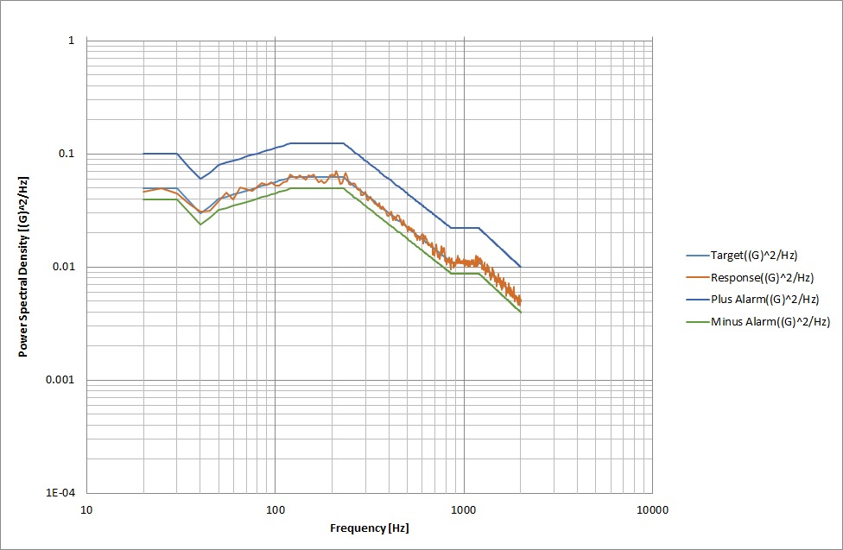

**Figure 6.1 EM vibration test spectrum**

## 6.1 DC/DC Converter Test (for overcharge)

The output of the solar cell is regulated by one DCDC converter to charge the battery. Connect an external power supply to the Backplane board and simulate the input voltage from the solar cell. Then, measure the DCDC output voltage from the connector that connects to the battery. The battery overcharge voltage is 4.8 V or higher. When the DC/DC input voltage is supplied 4.8V through 5.2V to 8V , we confirmed the DC/DC output voltage is approximately 4.2V by measuring the voltage at the 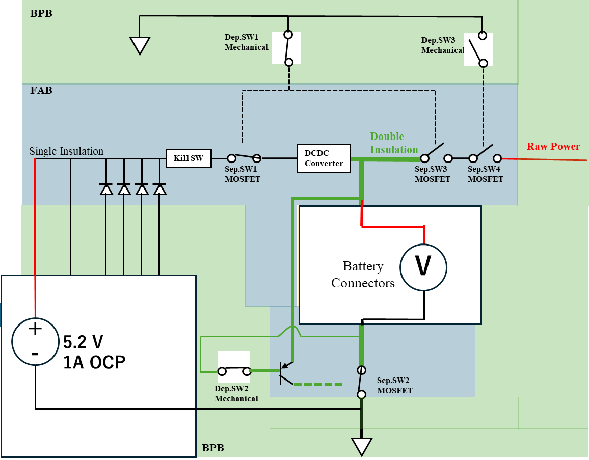battery slot.

**Figure 6.1-1 Schematic Diagram of EPS Overcharge Protection Circuit**

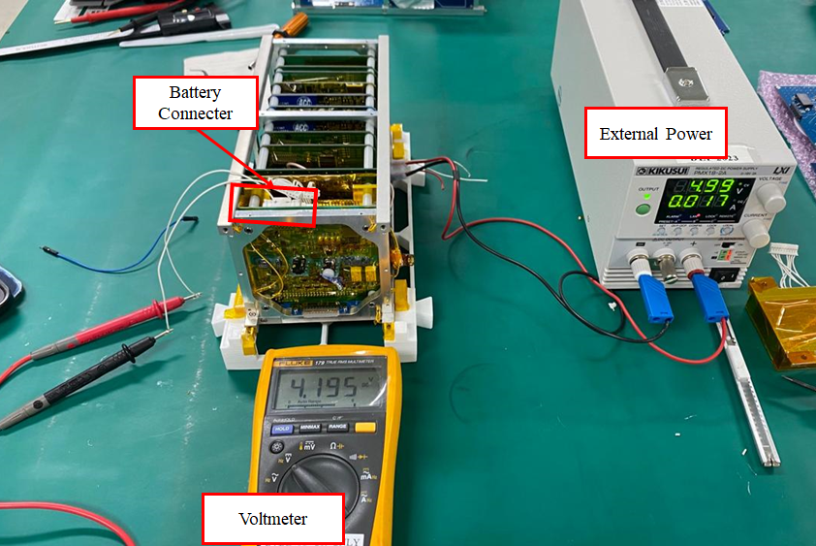

**Figure 6.1-2 DC/DC Converter Test Setup**

#### Table 6.1-1 EM Test Results of the DRAGONFLY’s DC/DC Converter

|  |  |  |  |  |  |  |
| --- | --- | --- | --- | --- | --- | --- |
|  | **Before environment test** | | | **After environment test** | | |
| **Solar Panel Axis** | **DC Input Voltage (V)** | **Input Current (A)** | **DC/DC Output (V)** | **DC Input Voltage (V)** | **Input Current (A)** | **DC/DC Output (V)** |
| -X-axis | 4.80 | 0.022 | 4.197 | 4.80 | 0.021 | 4.197 |
| 5.00 | 0.022 | 4.197 | 5.00 | 0.020 | 4.197 |
| 5.20 | 0.022 | 4.197 | 5.00 | 0.022 | 4.197 |
| 5.50 | 0.023 | 4.197 | 5.50 | 0.022 | 4.197 |
| 6.00 | 0.023 | 4.197 | 6.00 | 0.022 | 4.197 |
| 6.50 | 0.023 | 4.197 | 6.50 | 0.022 | 4.197 |
| 7.00 | 0.023 | 4.197 | 7.00 | 0.022 | 4.197 |
| 7.50 | 0.023 | 4.197 | 7.50 | 0.022 | 4.197 |
| 8.00 | 0.023 | 4.197 | 8.00 | 0.022 | 4.197 |

#### Table 6.1-2 FM Test Results of the DRAGONFLY’s DC/DC Converter before FM Vibration Test

|  |  |  |  |
| --- | --- | --- | --- |
| **Solar Panel​** | **DC Input Voltage (V)​** | **Input Current (A)​** | **DC/DC Output (V)​** |
| **-X Axis​** | 4.80 | 0.017​ | 4.195 ​ |
| 5.00 | 0.016​ | 4.195​ |
| 5.20 | 0.021 | 4.195 |
| 5.50 | 0.027​ | 4.194​ |
| 6.00 | 0.022​ | 4.194​ |
| 6.50 | 0.023​ | 4.194​ |
| 7.00 | 0.023​ | 4.194​ |
| 7.50 | 0.023​ | 4.194​ |
| 8.00 | 0.023**​** | 4.194​ |

After the satellite is assembled and vibration test is performed, the DCDC measuring points on the FAB board are not directly accessible. The buck functionality test of the DCDC can be verified by using the battery voltage monitoring port using the programming cable and board. As the external power supply is in parallel connection to the DCDC input capacitor and battery monitoring port is also in parallel connection to the output capacitor. So, the measure points are different but have the same connection and the buck functionality of DCDC was tested as shown in Figure 6.1-3. In the test setup, the RBF is plugged in, and deployment switches are in released condition.

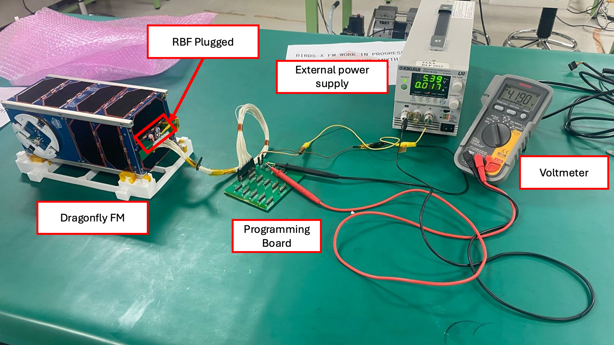

Figure 6.1-3 DC/DC Converter Test measurement after FM Vibration Test

***Table 6.1-3 Results for FM Test after Vibration Test***

|  |  |
| --- | --- |
| Power Supply (V)​ | DC/DC Output ​(V) |
| 4.8​0 | 4.190​ |
| 5.0​0 | 4.189​​ |
| 5.2​0 | 4.189​ |
| 5.40 | 4.189 |

#### 6.2 DC/DC Converter Test (Over Discharge and external short)

The DCDC converter functions as an over-discharge and short-circuit protection device. There is no reverse current flow from the output side of the DCDC converter to the input side. In the test, an external power supply from 3.8V to 4.2V is connected instead of a battery and the input and output voltages of the DCDC converter were measured. If no voltage is applied to the input side when a voltage is applied to the output side, the circuit is disconnected, and no reverse current flow occurs. EM after vibration and FM before vibration test results for DRAGONFLY are shown in Tables 6.2-1, Table 6.2-2. Protective devices are functionally tested for flight products before/after FM vibration test. The output of the DC/DC converter remains even when voltage is applied to the output of the DC/DC convertor, and no reverse current is generated. Hence, the DC/DC converters functionally protect the battery from over-discharging and short-circuit.

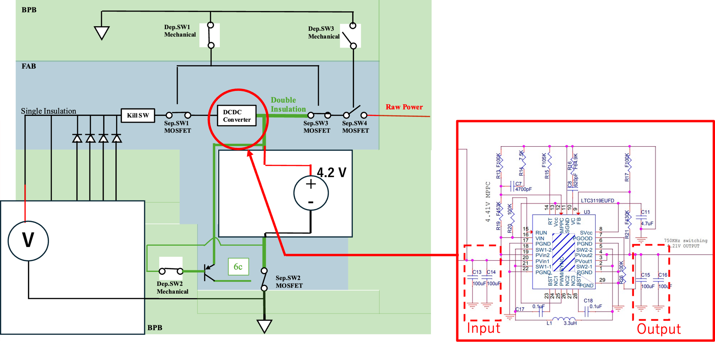

Figure 6.2-1 DC/DC Converter Test Measurement points

#### Table 6.2-1 Results for EM Test after Vibration test

|  |  |  |
| --- | --- | --- |
| Power Supply (V)​ | DC/DC Output (C15)​ | DC/DC Input (C13)​ |
| 3.8​0 | 3.757​ | 1.259 |
| 4.0​0 | 3.958 ​ | 1.260 |
| 4.2​0 | 4.161 | 1.259 |

#### Table 6.2-2 Results for FM Test before Vibration

|  |  |  |
| --- | --- | --- |
| Power Supply (V)​ | DC/DC Output (C15)​ | DC/DC Input (C13)​ |
| 3.8​0 | 3.582​ | 1.267​ |
| 4.0​0 | 3.726​ | 1.266​ |
| 4.2​0 | 3.965​ | 1.265​ |

Table 6.2-1, 6.2-2 shows a voltage value of more than 1V on the input side, so we reviewed the test setup and tested again. EM was used for this test. RBF 1 and 2 are removed and DepSW3 is pressed, then the voltage is applied at the output side of DC/DC converter and observed the voltage at the input side as shown in Figure 6.2-2. The results confirm there is no reverse current in the DC/DC converter as shown in Table 6.2-3. The reason why we observed the voltage value of more than 1V is that DepSW3 was not pressed in the previous test so satellite is powered ON. The current sensor (LMP8640) at the solar panel input side was also ON which was the reason to appear voltage at input side of DC/DC. As the EPS system is same for EM and FM, it can be concluded the FM DC/DC test results will have same results as the EM.

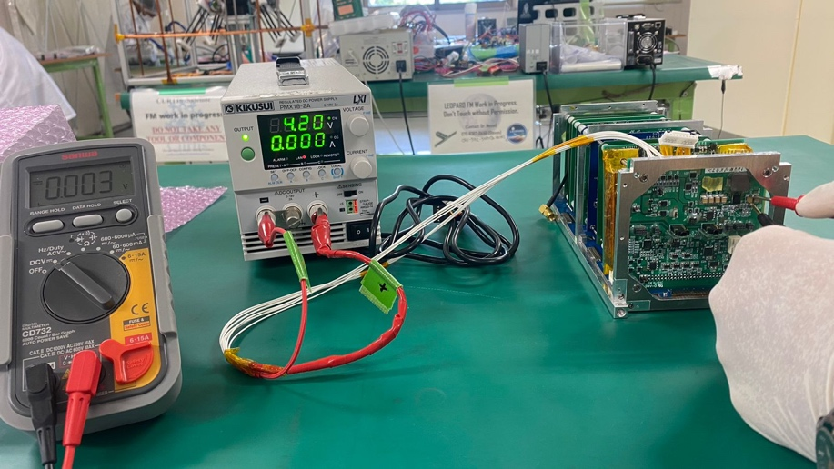

Figure 6.2-2 DCDC over discharge test with EM with DepSW3 was pressed

#### Table 6.2-3 Results for EM with DepSW3 was pressed

|  |  |  |
| --- | --- | --- |
| Power Supply (V)​ | DC/DC Output (C15)​ | DC/DC Input (C13)​ |
| 3.8​0 | 3.757​ | 0.004 |
| 4.0​0 | 3.958 ​ | 0.003 |
| 4.2​0 | 4.161 | 0.003 |

## 6.3 Diode Test

The purpose of the diode test is to verify that no current flows through the diode into the solar cells. For -X and +X panels the diode is in panel. Soin order to check if current flows in the reverse direction of the diode towards the solar cell, a resistor is connected at Pin 8 of the solar panel board as it is connected to the anode side of the diode under test which then connected in series with a Digital Multimeter (set as ammeter) with negative probe connected to negative terminal of the power supply and the solar panel board Pin 12 (GND) as shown in Figure 6.2-1. The resistor serves as a load that will draw current from the solar panel board or from the battery. Pin 8 of the solar panel board header is the power line towards the battery. It is connected to the power supply to serve as the battery of the satellite. When the power supply is activated, it will provide current flow to the solar panel board passing through Pin 8. However, with the diode in between, there should be no current flowing towards Pin 4 of the board header as read by the connected digital multimeters (see Figure 6.3-2). For Y and Z panels, the diodes are located in the FAB board. For these diodes, the external power supply with 5V and 1A is given to the external power terminal and electronics load is connected to the Y and Z of 12 pin solar panel connector as shown in Figure 6.3-3 and 6.3-4. There should be no current draw from the electronic load.

Table 6.3-1 and Tables 6.3-2 show the FM test results for DRAGONFLY, there is very little reverse current flow (mA) from the diode towards the load resistor. This proves that the diode functions properly in blocking substantial reverse currents from the battery or the DC/DC converters.

|  |  |
| --- | --- |
| **Figure 6.3-1 Diode Test Setup -X and +X panels Block Diagram** | **Figure 6.3-2 Actual Test Setup** |

#### Figure 6.3-3 Diode Test Setup Y and Z panels Block Diagram Table 6.3-1. FM Diode Test Results

Table 6.3-1. FM Diode Test Results

|  |  |  |  |
| --- | --- | --- | --- |
| **Panel ​** | **Power Supply (V)​** | **Load Current (A)​** | |
| **Diode 1** | **Diode 2** |
| -X​ | 5​.20 | 0.00​ | 0.00​ |
| +X​ | 5​.20 | 0.00​ | 0.00​ |
| -Y​ | 5​.20 | 0.00​ |
| +Y​ | 5​.20 | 0.00​ |
| -Z​ | 5​.20 | 0.00​ |
| +Z​ | 5​.20 | 0.00​ |

A diode is also on the line that charges the battery with an external power supply.In the event of a short circuit between this diode and the access port that connects the external power supply, this diode can prevent backflow from the battery.

In order to check if current flows in the reverse direction of the diode, an electronic load is connected through the power supply terminal to draw current from the battery (Figure6.2-4). The test results for FM are shown in Table 6.2-5. There is no reverse current flow (mA) from the diode towards the electronic load. This proves that the diode functions properly in blocking substantial reverse currents from the battery.

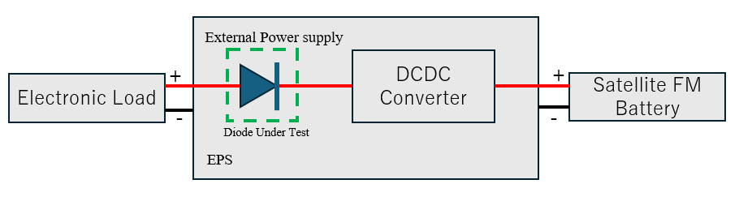

**Figure 6.3-4 Diode Test Setup Block Diagram**

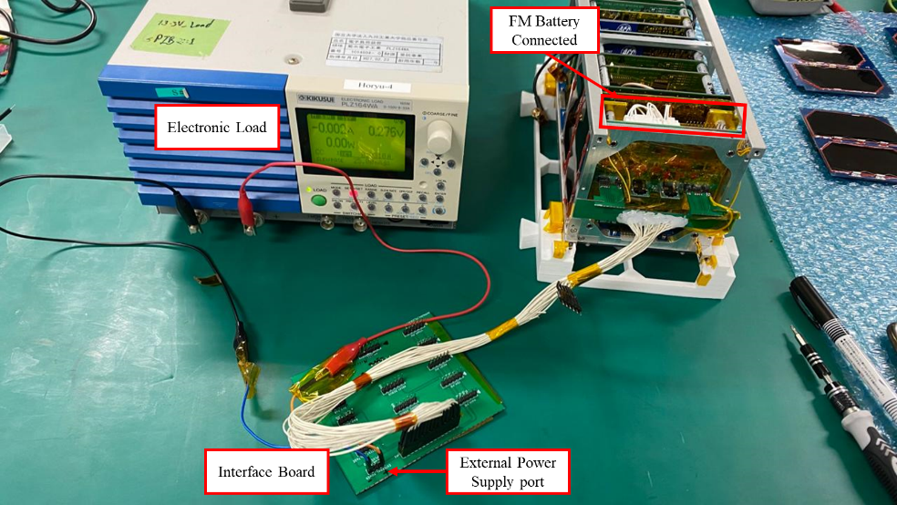

**Figure 6.3-5 Actual Test Setup**

#### Table 6.3-2 Diode Test Results for Charging Line

|  |  |  |  |
| --- | --- | --- | --- |
| **Set Load Voltage (V)** | **Set Load Current (A)** | **Actual Load Voltage (V)** | **Actual Load Current (A)** |
| 5.00 | 1.000 | 0.276 | 0.000 |

**6.4** **MOSFET Test****:** MOSFETs are controlled by mechanical deployment switches, hence their functionality can be summarized as from functionality of deployment switches.

As per Figure 4.2 (EPS Inhibit Block Diagram), SepSW1 and SepSW2 are controlled by DepSW1. SepSW3 is controlled by DepSW3, and SepSW4 is controlled by DepSW2.

Separation Switches are the inhibit switches, and their verification methods are as described below:

**SepSW1:**Is controlled by DepSW1 mechanical switch, and is between the solar panels and the battery. Hence when DepSW1 is released, solar panels should supply power to battery to charge. But if DepSW1 is pressed, SepSW1 should open and Supplied Voltage should read 0V.

**SepSW2:**Is controlled by DepSW2 mechanical switch and is between the battery negative terminal and satellite ground. Hence when DepSW2 is released, the battery should supply power to the loads, and serial data will be displayed on screen. But if DepSW2 is pressed, SepSW2 should open and the battery power will be cut off, hence no power supply to the load; meaning no serial data output.

**SepSW3:**Is controlled by DepSW1 mechanical switch and is between the battery and the load. Hence when DepSW1 is released, battery should supply power to load and serial data will be displayed on monitor. But if DepSW1 is pressed, SepSW3 should open and there will be no power supplied to the load side.

**SepSW4:**Is controlled by DepSW3 mechanical switch and is also between the battery and the load. Hence when DepSW3 is released, battery should supply power to load and serial data will be displayed on monitor. But if DepSW3 is pressed, SepSW4 should open and there will be no power supplied to the load side. Reference figures from Figure 5.1 to 5.4.

## 6.5 Insulation Process

Before inserting into the satellite backplane, the inhibit circuit components in the EPS board and other EPS components/parts are covered or wrapped with insulator materials to ensure the insulation. For this purpose, following instructions are followed:

* The MOSFETs, DCDC converters, and diodes are covered by RTV.
* Deployment switch cables are covered by shrinkable tube and Kapton tape twice.
* The batteries, the aluminum box used as the battery case and the battery cables are covered by Kapton tape twice.
* Power lines on the surface of a circuit board are separated by 1mm or more, and the surface is covered with Kapton tape for insulation.

The results of the insulation treatment are shown in Figure 6.5-1.

The following figures show the insulation methods applied on FM components.

|  |  |
| --- | --- |
|   ***FAB – Front*** |   ***FAB – Back*** |
| ***Back Plane Board – Front*** |   ***Back Plane Board – Back*** |
| ***Battery Pack – Set-Up*** | ***Battery Pack – Capton Taped & Assembled*** |

**Figure 6.5-1** DRAGONFLY **FM Double Insulation**

# 7 Conclusion

Based on the tests and visual verifications conducted, DRAGONFLY Flight Model has appropriate and functional inhibits as well as functional protection circuits.